Predicting Low Muscle Mass in U.S. Adults: A Machine Learning and Bayesian Analysis of NHANES 2011–2018

Name: Adiel Mallik
Student Number: 501411208
Supervisor: Professor Ashok Bhowmick
Practical Data Science and Machine Learning Certificate
Chang School of Continuing Education
Toronto Metropolitan University

CIND860 – Capstone Project
June 13, 2026

Introduction
Sarcopenia defined as the progressive loss of skeletal muscle mass, strength, and function, is increasingly recognized as a significant public health concern beyond the older adult population (Zhao et al., 2024). While sarcopenia has traditionally been studied in adults over 60, there is growing evidence that low appendicular skeletal muscle mass index (ASMI) develops as early as the third decade of life, and that the metabolic and lifestyle conditions driving it are well established by midlife (Kim et al., 2024). Identification of at-risk individuals before functional decline becomes apparent is therefore clinically meaningful, yet population-level predictive tools targeting the 20–59 age window remain limited.
This project uses data from the National Health and Nutrition Examination Survey (NHANES) 2011–2018 to develop and evaluate machine learning models for classifying low muscle mass which is defined as sex-specific bottom-20th-percentile ASMI derived from dual-energy X-ray absorptiometry (DXA), in a nationally representative sample of 14,347 U.S. adults aged 20–59. Two analytical themes from the CIND 860/840 curriculum are applied: data mining, drawing on ensemble classifiers (Random Forest, XGBoost, Support Vector Machine) with SHAP-based interpretability; and Bayesian data analysis, using Bayesian logistic regression with priors informed by published epidemiological estimates. The integrated analysis addresses a gap in the existing literature: no study to date has combined dietary, behavioral, anthropometric, and clinical covariates within a single machine learning (ML) and Bayesian framework for predicting low muscle mass specifically in working-age U.S. adults.
The research questions guiding this project are as follows. First, can a machine learning model trained on routinely collected NHANES variables accurately predict low muscle mass in U.S. adults aged 20–59, and which physical, dietary, and demographic features drive that prediction? Second, does predictive accuracy differ across sex, age group, and racial/ethnic subgroups, and can these differences be attributed to identifiable feature interactions? Third, what does a Bayesian logistic regression model, with priors informed by published sarcopenia prevalence and logistic regression coefficients, reveal about the posterior uncertainty of key predictors, and how does it compare to the traditional machine learning models?
Literature Review
Sarcopenia as a Public Health Burden: Prevalence, Disparities, and Mortality Risk
The epidemiological case for treating low muscle mass as a clinical priority rests on two well-established findings: it is common across the lifespan, and it independently predicts hard outcomes including all-cause mortality (Shafiee et al., 2017; Wang et al., 2023). Du et al. (2018) analyzed NHANES 1999–2004 data from 4,367 adults and found substantial racial and ethnic variation in sarcopenia prevalence, with Hispanic males showing the highest rates (26.8%) compared to Non-Hispanic White males (15.5%) and Non-Hispanic Black males (8.6%). The same study identified sarcopenic obesity which is the co-occurrence of low muscle mass and excess adiposity, as the phenotype carrying the greatest functional burden (Du et al., 2018). Critically, these differences persisted after adjustment for age and sex, which directly supports the inclusion of race/ethnicity as a covariate and potential interaction term in the present model (Du et al., 2018).
The mortality consequences of muscle wasting are well established at the population level (Zhou et al., 2023). A 2023 meta-analysis by Zhou et al., encompassing 49 prospective cohort studies and 878,349 participants with follow-up periods of 2.5 to 32 years, reported that muscle wasting was associated with an all-cause mortality relative risk of 1.36 (95% CI: 1.28–1.44), a cardiovascular disease mortality RR of 1.29, and a respiratory mortality RR of 1.36 (Zhou et al., 2023). Notably, muscle mass predicted mortality independently of whether grip strength was also reduced, which distinguishes muscle mass as a clinically meaningful outcome in its own right rather than merely a proxy for functional capacity (Zhou et al., 2023). The dose-response relationship identified in that meta-analysis being approximately linear between mid-arm muscle circumference and mortality risk lends further support to treating ASMI as a continuous variable in sensitivity analyses alongside the binary classification primary outcome (Zhou et al., 2023).
Directly relevant to the present dataset is Kim et al (2024), who linked NHANES 1999–2006 and 2011–2018 data from 16,839 adults to the NHANES Public-Use Linked Mortality File using Cox proportional hazards models (Kim et al., 2024). Metabolically unhealthy individuals with low muscle mass had the highest all-cause mortality hazard ratio at 2.00 (95% CI: 1.56–2.56), and the cardiovascular disease (CVD) mortality hazard ratio (HR) for metabolically healthy obese individuals with low muscle mass reached 3.18 (95% CI: 1.53–6.65) (Kim et al., 2024). The fact that this study uses the same NHANES cycles as the current project, and that diabetes status which is a key moderator in that analysis that is included as a covariate in the present feature set, makes these findings directly applicable as a substantive baseline (Kim et al., 2024).
Measuring Muscle Mass in Epidemiological Research: DXA, ASMI, and Operational Definitions
It is important to clarify what sarcopenia researchers are measuring because the answer is less straightforward than it appears. There is no single universally accepted definition of low muscle mass. Three major clinical bodies have each proposed their own diagnostic criteria: the Foundation for the National Institutes of Health (FNIH), the European Working Group on Sarcopenia in Older People (EWGSOP2), and the Asian Working Group for Sarcopenia (AWGS 2019). Each specifies a different minimum threshold for what counts as "low" appendicular skeletal muscle mass index (ASMI which is the total mass of the arm and leg muscles divided by height squared), and each has a set of cutoffs was derived primarily from studies of adults aged 60 and older. When applied to working-age adults, these fixed thresholds consistently underestimate the true burden of muscle loss in that group, because they were never calibrated on younger populations. Apply FNIH criteria to the same dataset and you get one prevalence estimate; apply EWGSOP2 and you get another. The choice of definition is therefore itself a research decision, not a background administrative detail and one that directly affects how many people are classified as cases.
Zooravar (2025) applied FNIH criteria to 5,925 NHANES participants across eight cycles (1999–2006 and 2011–2018), linking DXA-derived ASMI data to the NHANES mortality file with a mean follow-up of 125 months (Zooravar, 2025). Sarcopenia was associated with progressively worse cardiovascular-kidney-metabolic (CKM) syndrome staging: Odds Ratio (OR) = 2.24 for Stage 2, OR = 3.33 for Stage 3, and OR = 3.50 for Stage 4 and independently predicted all-cause mortality (HR = 1.53) and cardiovascular mortality (HR = 1.90) (Zooravar, 2025). The clinical covariates used in that study which were: diabetes, hypertension, and kidney function markers overlap substantially with the feature set in the present project, which strengthens the comparability of the findings and provides a direct substantive benchmark against which the present model's predictors can be evaluated (Zooravar, 2025).
A more direct methodological comparator comes from Xie et al. 2025, who analyzed the same NHANES 2011–2018 cycles used here with a sample of 7,455 adults aged 20 and older (Xie et al., 2025). Using weighted multivariable logistic regression with DXA-derived ASMI as the outcome, that study identified an inverse U-shaped relationship between BMI and low muscle mass (Xie et al., 2025). Specifically, they found that both underweight and obese phenotypes were associated with elevated risk (Xie et al., 2025). They also found that this relationship was moderated significantly by sex and race/ethnicity. Income-to-poverty ratio was also an independent predictor (Xie et al., 2025). These findings have a direct implication for how the present model should be constructed. Standard logistic regression assumes that the relationship between each predictor and the outcome follows a fixed, pre-specified shape. An example would be if higher BMI is always associated with higher or always lower risk, in a straight line. When the true relationship is curved or changes direction, as it does here with BMI, extra terms to the model must be manually added to capture that shape. The challenge is that this can only be done reliably one already knows what shape to expect. When the shape is unknown in advance or when it differs across subgroups, as Xie et al. (2025) found across sex and racial/ethnic groups, standard logistic regression will miss it.
Random Forest and XGBoost operate differently. Rather than fitting a single equation to the data, both methods build many decision trees that repeatedly split the data based on predictor values. Through this process, they naturally detect relationships that go up and then back down, or that behave differently in one subgroup than another, without the analyst needing to specify this in advance. The choice of these methods proposed, in this case Random Forest and XGBoost follows directly from what the literature shows the BMI-ASMI relationship is in this population (Xie et al., 2025).
In the present project, the outcome variable is defined as the sex-specific bottom-20th-percentile ASMI, computed separately for males (cutoff: 8.13 kg/m²) and females (cutoff: 6.23 kg/m²) from the full analytical sample. This data-driven cut point approach was chosen over published absolute thresholds for two reasons. First, the FNIH and EWGSOP2 cutoffs were derived from community-dwelling older adults and have not been validated for a 20–59 age range (Cruz-Jentoft et al., 2019; Studenski et al., 2014). Second, the use of population-specific percentile-based cut points, rather than fixed external thresholds is a recognized and methodologically justified approach when the reference population differs meaningfully from the study sample (Bianchi et al., 2013; Ida et al., 2021). The 20th percentile as a cut point for low ASMI has been applied in prior sarcopenia research precisely because fixed SD-based cutoffs derived from young adult reference populations tend to produce implausibly low prevalence estimates in certain groups (Coin et al., 2013; Yamada et al., 2021). The 20th percentile in the present sample yielded a prevalence of exactly 20%, n = 2,179 cases out of 10,891 participants with complete DXA data. This falls within the range of low muscle mass estimates reported in the literature for working-age adults (Jung et al., 2023; Zhao et al., 2024) and confirms that the sex-specific cut point procedure produced a clinically plausible outcome distribution.
Lifestyle and Anthropometric Predictors of Skeletal Muscle Mass: Protein Intake, Physical Activity, and Body Composition
Three sets of findings from the NHANES literature directly motivate the inclusion of dietary, behavioral, and anthropometric features in the present model. Jun et al. (2021) analyzed NHANES 2011–2014 data from 2,417 adults aged 40–59 which was the upper half of the age range they examined, and they found a significant dose-response relationship between protein intake and both ALM/BMI and grip strength (Jun et al., 2021). Participants consuming at least 1.2 g per kg body weight daily had significantly greater muscle mass than those consuming below the recommended dietary allowance of 0.8 g/kg, and the effect was present in both sexes. This finding is directly relevant: the NHANES dataset used here includes two 24-hour dietary recall estimates for protein and total energy intake, and the dose-response finding suggests that protein intake may perform better as a categorical or spline-transformed feature than as a raw continuous variable in the modeling pipeline.
Bradlee et al. (2017) examined NHANES 2003–2006 data from 2,425 adults aged 50 and older and found that the relationship between physical activity and ASMI was not additive with protein intake but synergistic (Bradlee et al., 2017). Vigorous aerobic activity was consistently associated with higher ASMI regardless of protein intake level, but muscle-strengthening exercises only yielded higher ASMI in individuals who also had adequate protein intake (Bradlee et al., 2017). A particularly noteworthy finding was that among obese individuals with low protein intake (below 70 g/day), muscle-strengthening exercise was paradoxically associated with lower ASMI relative to inactive peers (Bradlee et al., 2017). This pattern is precisely the type of non-additive interaction that standard logistic regression models cannot detect without explicit interaction term specification, but that tree-based ensemble models identify automatically through recursive partitioning.
Wei et al. (2025) analyzed NHANES 2011–2014 data from 5,466 adults using smooth curve fitting and identified a threshold effect at a body roundness index (BRI) of 3.42, below which BRI had a modest positive association with grip strength, and above which higher BRI was associated with declining muscle quality (Wei et al., 2025). BRI is a composite anthropometric index derived from waist circumference and height; both variables are present in the current NHANES dataset. BRI offers a more sensitive measure of central adiposity than BMI alone (Wei et al., 2025). The threshold effect identified in that study is a real-world example of the non-linear feature-outcome structure that justifies the use of non-parametric machine learning models, and BRI will be computed as an engineered feature in the present modeling pipeline (Wei et al., 2025).
Machine Learning Approaches to Sarcopenia Prediction: Ensemble and Bayesian Methods
The methodological literature most directly relevant to the present project comes from three recent publications that apply machine learning to sarcopenia prediction in large epidemiological cohorts. Olshvang et al. (2024) used NHANES data from multiple cycles alongside the Look AHEAD study for external validation, comparing Random Forest, XGBoost, and LassoNet for predicting DXA-derived ASMI, ALM, and lean body mass from anthropometric variables (Olshvang et al., 2024). LassoNet achieved R² = 0.86 for ALM prediction on NHANES, substantially outperforming the best traditional anthropometric equation (R² ≈ 0.73) (Olshvang et al., 2024). SHAP analysis in that study identified heavy metal exposures, specifically, lead and cadmium as novel muscle mass predictors, demonstrating that SHAP can generate new biological hypotheses beyond ranking known features (Olshvang et al., 2024). The present project extends this framework by incorporating dietary, behavioral, and clinical covariates beyond anthropometrics, and by framing the problem as binary classification rather than continuous regression.
Yu et al. (2025) applied XGBoost with SHAP to sarcopenia prediction in 1,080 older adults with cardiovascular disease from the China Health and Retirement Longitudinal Study, achieving AUC = 0.867 and F1 = 0.871 (Yu et al., 2025). Sex-specific SHAP analysis found that HDL cholesterol and sleep quality were significant predictors in males only, while depressive symptoms (CESD score) were significant in females only (Yu et al., 2025). This finding validates the planned subgroup interaction analysis in the present project. That study also applied SMOTE for class balancing, a choice the present project deliberately avoids on the grounds that generating synthetic medical records risks introducing non-physiological patterns and degrading probability calibration; class-weighted loss functions within the XGBoost and Random Forest algorithms will be used instead.
Chong (2025) provides perhaps the most directly comparable methodological reference, examining sarcopenia prediction in 1,119 middle-aged Korean adults aged 40–64 using logistic regression, SVM, Random Forest, and XGBoost, with external validation on an independent year-cohort (Chong, 2025). Logistic regression achieved AUC = 0.85 and sensitivity = 0.92 on external validation, outperforming the tree-based models, which showed severe overfitting (training AUC = 1.00 but specificity = 0% on external validation) (Chong, 2025). This is an important cautionary finding: with a sample of only approximately 1,100 participants, Random Forest and XGBoost overfit extensively (Chong, 2025). The present project uses n = 14,347 which is more than twelve times larger. This substantially reduces this risk, though overfitting will still be addressed through five-fold stratified cross-validation and a 70/30 train-test split. The same study confirmed that protein intake, sex, age, and obesity status are the strongest predictors of sarcopenia in the middle-aged group, consistent with the feature importance findings from the other studies reviewed above (Chong, 2025).
Identified Gap and Project Contribution
Taken together, the reviewed literature identifies a clear methodological gap. No published study has simultaneously combined dietary intake, physical activity, anthropometric, socioeconomic, and clinical covariates within a machine learning and Bayesian framework for predicting low muscle mass specifically in working-age U.S. adults using multi-cycle NHANES data. Prior ML studies either focus exclusively on anthropometric predictors (Olshvang et al., 2024), use non-U.S. populations (Chong, 2025; Yu et al., 2025), or are limited to older adult cohorts where sarcopenia has a different etiology than in midlife (Dodds et al., 2015; Shaw et al., 2017). The present project addresses this gap by applying both data mining and Bayesian methods to a richer, nationally representative feature set, using class-weighted imbalance handling rather than synthetic oversampling, and reporting both SHAP-based global feature importance and sex-stratified subgroup analyses.
Data Description
Source and Structure
The dataset is drawn from four cycles of the National Health and Nutrition Examination Survey (NHANES): 2011–2012, 2013–2014, 2015–2016, and 2017–2018. NHANES is a continuous, cross-sectional program administered by the National Center for Health Statistics (NCHS) and is designed to assess the health and nutritional status of the non-institutionalized U.S. civilian population using a complex stratified multistage probability sampling design. Data from the four cycles were downloaded directly from the CDC NHANES server using publicly available XPT files and merged by SEQN (respondent sequence number). The merged analytical dataset contains 14,347 adults aged 20–59 years: 7,499 female and 6,848 male.
Variables and Feature Set
The outcome variable is low_muscle_mass, a binary indicator equal to 1 for participants in the sex-specific bottom 20th percentile of appendicular skeletal muscle mass index (ASMI, kg/m²). ASMI was derived from DXA-measured four-limb lean mass (sum of arm and leg lean tissue in grams, divided by 1,000 to convert to kilograms, then divided by height in metres squared). The sex-specific 20th-percentile cutoffs were 8.13 kg/m² for males and 6.23 kg/m² for females, yielding 2,179 cases of low muscle mass (20% prevalence) among the 10,891 participants with complete DXA data. This exact balance between cases and available non-cases means that class imbalance, while present relative to the full 14,347-person sample, is moderate rather than severe.
Predictor variables span five domains. Demographic and anthropometric variables include age (years), sex, race/ethnicity (five categories: Non-Hispanic White, Non-Hispanic Black, Hispanic, Asian, Other), height (cm), weight (kg), BMI (kg/m²), and waist circumference (cm). Dietary variables, derived from two 24-hour dietary recalls, include total protein intake (g/day) and total energy intake (kcal/day); calcium (mg/day) and vitamin D (mcg/day) are also included given their established roles in musculoskeletal metabolism. Socioeconomic variables include the poverty income ratio, a continuous measure of household income relative to the federal poverty level. Clinical and health behaviour variables include diabetes status (binary), cardiovascular disease history (binary), self-reported smoking status, and physical activity level (MET-adjusted minutes per week of moderate and vigorous activity). Grip strength (maximum of four dynamometer trials in kg) is included as a feature for models using only the 2011–2013 cycles, where it is available.
Summary Statistics
Table 1 presents summary statistics for the full analytical sample, stratified by sex. Mean age was 39.37 years (SD = 11.49) overall, with no statistically significant difference between females (39.49, SD = 11.36) and males (39.24, SD = 11.62; p = 0.2). Significant sex differences were observed for all other continuous variables (all p < 0.001). Mean BMI was 29.36 kg/m² (SD = 7.46) overall; females had slightly higher BMI (29.85, SD = 8.18) than males (28.83, SD = 6.56). Mean ASMI was 8.45 kg/m² overall, with males averaging 9.39 (SD = 1.51) and females 7.54 (SD = 1.55), consistent with the well-established sexual dimorphism in appendicular lean mass. Mean appendicular lean mass was 24.04 kg (SD = 6.69) overall, 28.54 kg in males and 19.67 kg in females. Max grip strength was 39.48 kg (SD = 11.44) overall, 48.29 kg in males and 30.90 kg in females. Mean protein intake was 85.76 g/day (SD = 45.87) overall, 100.81 g/day in males and 71.90 g/day in females. Mean total energy intake was 2,238.80 kcal/day overall. The low muscle mass prevalence was exactly 20% in both sexes (p > 0.9), confirming that the sex-specific percentile cutoff procedure achieved the intended balance. Low grip strength which was defined as maximum grip below the FNIH cutoffs, was present in only 42 participants (0.6%), reflecting the young-to-midlife age range of this sample.
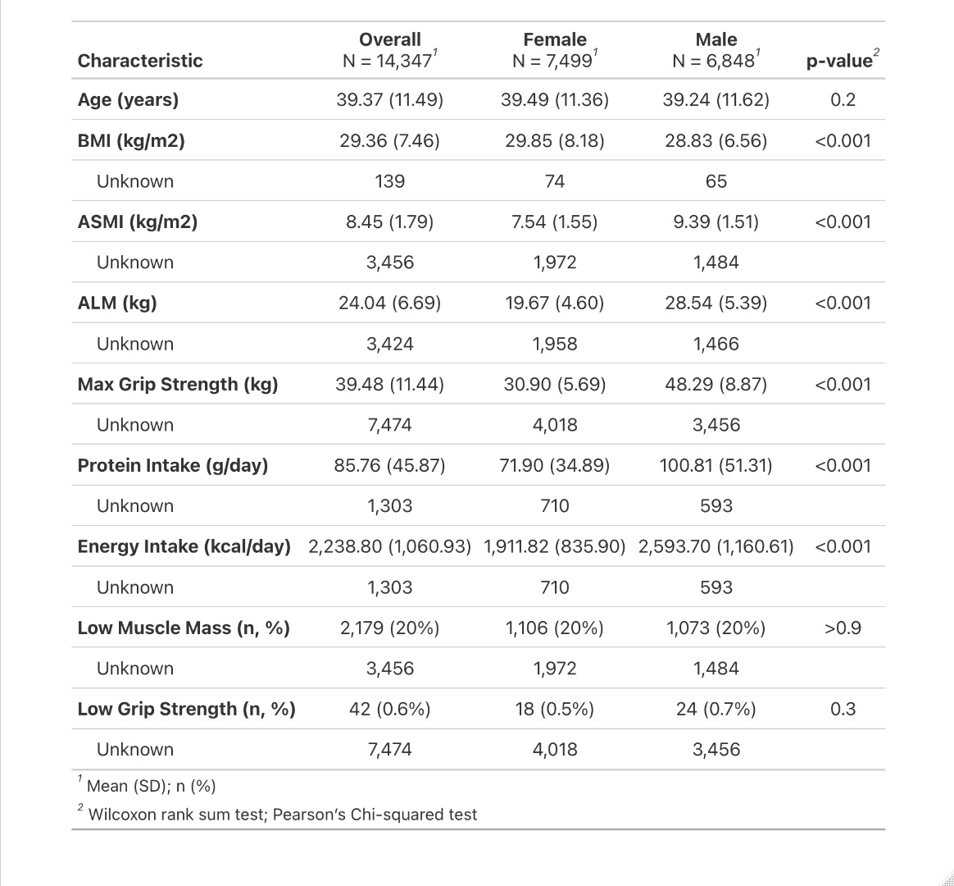
Table 1. Summary statistics for the NHANES 2011–2018 analytical sample (N = 14,347), stratified by sex.
Note. Values are mean (SD) unless otherwise noted. P-values from Wilcoxon rank sum test and Pearson chi-squared test.
Missing Data
Missing data patterns are summarized in Figure 1. The two variables with the highest missingness are max grip strength (52.1% missing) and ASMI/ALM (approximately 24%). Both are structural features of the NHANES sampling design rather than data quality failures. Grip strength was collected only in the 2011–2012 and 2013–2014 cycles via the Muscle Strength/Endurance (MGX) module, which was discontinued in 2015. ASMI and ALM missingness reflects the fact that DXA scans were administered to a probability subsample of eligible participants, not the full interview sample, in every cycle. Dietary variables (protein, energy, calcium, vitamin D), poverty income ratio, and physical activity each show approximately 9.1% missing data, consistent with non-response and exclusions from the 24-hour recall protocol. BMI, height, and weight are missing in fewer than 1% of participants. All missing data will be handled through multiple imputation using predictive mean matching for continuous variables and logistic imputation for binary variables, with 10 imputed datasets and pooled estimates reported following Rubin's rules.
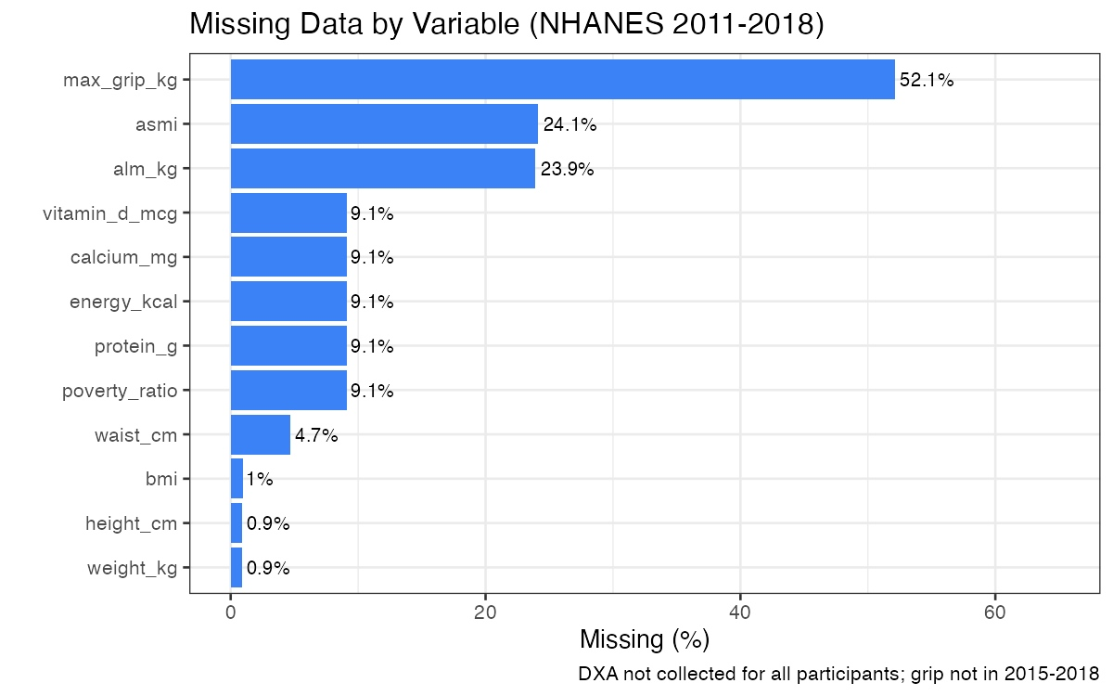
Figure 1. Missing data by variable, NHANES 2011–2018 (N = 14,347). DXA was not collected for all participants; grip strength data were not collected in the 2015–2018 cycles.
Exploratory Data Analysis
Figure 2 shows the distribution of ASMI by sex. The male distribution is centered at approximately 9.4 kg/m² and the female distribution at approximately 7.5 kg/m², consistent with published NHANES reference values. Both distributions are approximately unimodal and right-skewed, with the male distribution showing a longer upper tail. The overlap region between approximately 7 and 10 kg/m² confirms that sex must be controlled in all analyses and that sex-specific cutpoints are necessary for the outcome definition.
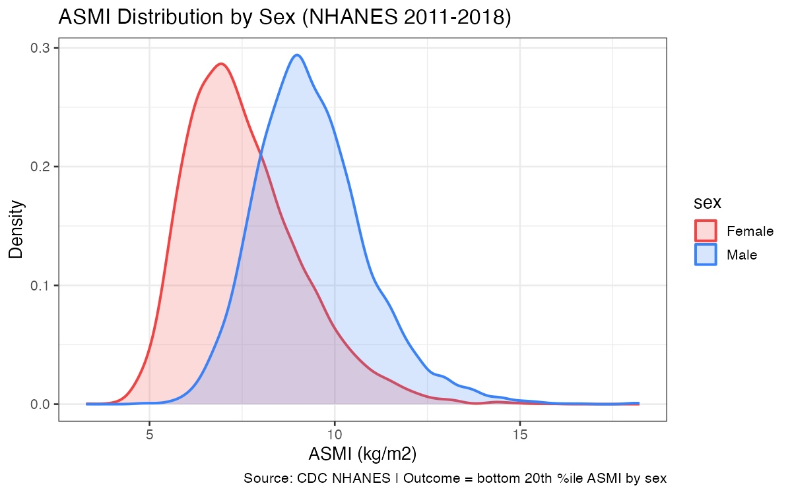
Figure 2. Distribution of ASMI (kg/m²) by sex, NHANES 2011–2018. Vertical dashed lines indicate sex-specific bottom-20th-percentile cutoffs (male: 8.13 kg/m²; female: 6.23 kg/m²).
Figure 3 shows low muscle mass prevalence by age group and sex. The U-shaped pattern with highest prevalence in the 20–29 group (22.6% females, 24.4% males), declining through the 40–49 decade (16.6% and 16.4%), then rising again in the 50–59 group (22.3% and 21.2%), is consistent with the known trajectory of muscle mass across adulthood. The initial peak in young adults likely reflects participants who are underweight or have constitutionally low muscle mass; the upturn in the 50s reflects age-related muscle loss beginning in earnest. There are no statistically significant sex differences in low muscle mass prevalence within any age decade (p > 0.9 overall), which follows from the use of sex-specific percentile cutoffs.
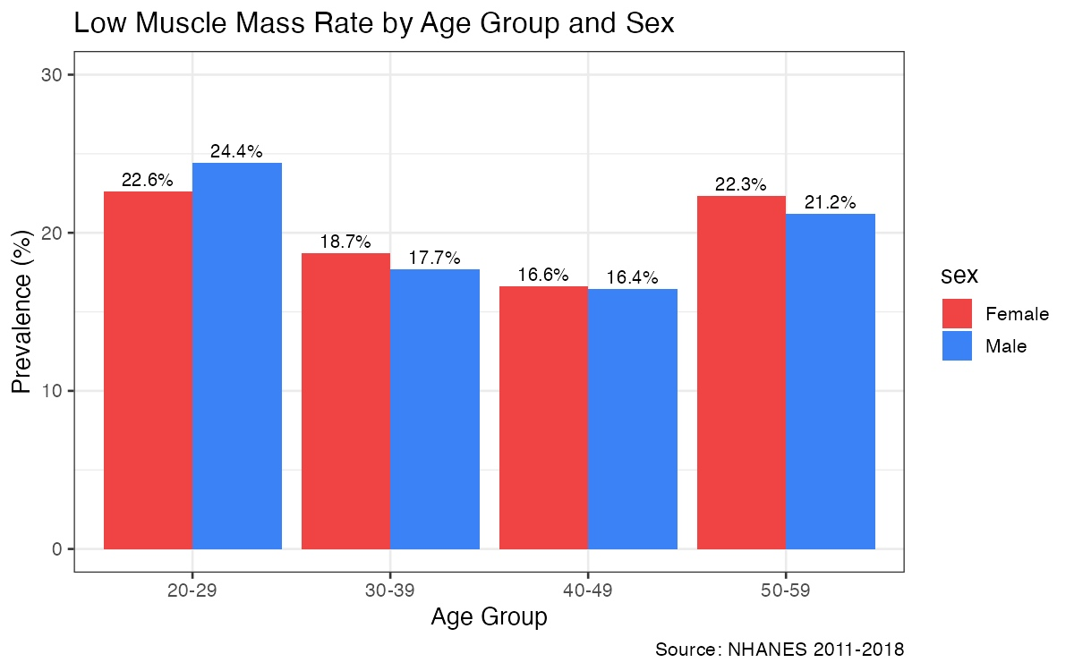
Figure 3. Low muscle mass prevalence (%) by age group and sex, NHANES 2011–2018.
Figure 4 shows the relationship between grip strength and ASMI, stratified by sex. A positive linear association is evident in both sexes, with males showing higher absolute values on both dimensions. The regression slopes are similar across sexes, though the confidence bands are wider at higher ASMI values, particularly in males which reflects the sparser data at the high end of the muscle mass distribution. This association supports grip strength as a predictor in models restricted to the 2011–2013 cycles, and the sex difference in intercepts further confirms the need for sex-stratified or sex-interaction analyses.
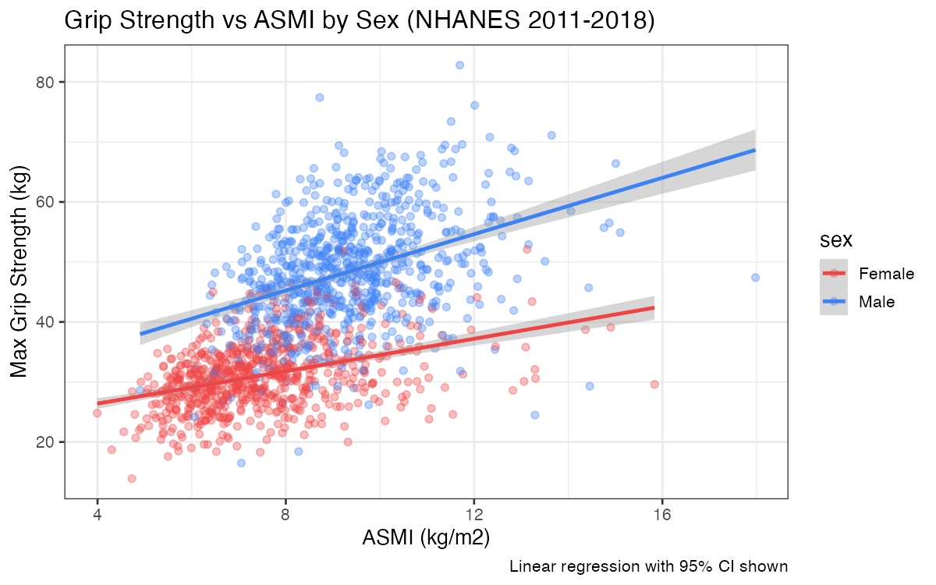
Figure 4. Scatterplot of maximum grip strength (kg) versus ASMI (kg/m²) by sex, NHANES 2011–2018. Lines show linear regression fits with 95% confidence intervals.
Identification of Abnormal Data
Outlier screening was conducted on the continuous predictor and outcome variables using the 1.5 × IQR rule applied within sex-specific groups. Three categories of abnormal values were identified. Twenty-two participants had BMI exceeding 60 kg/m²; these extreme values are biologically plausible in a population-based sample but may exert undue influence on regression-based models, and they will be flagged for sensitivity analyses. Eighteen participants reported total dietary protein intake exceeding 300 g/day from the 24-hour recall; given that a single 24-hour recall captures only one day of dietary intake and is subject to reporting and coding errors, values above the 99.5th percentile for each sex will be Winsorized to that threshold rather than deleted. Grip strength values below 5 kg which were present in four participants were confirmed against the raw NHANES data and retained as plausible for individuals with severe physical impairment.
No duplicate SEQN values were present in the merged dataset. Age was confirmed to be within the 20–59 inclusion range for all 14,347 participants. ASMI values below 3 kg/m² or above 20 kg/m² which are thresholds outside any published reference range for adults were not observed. The dataset link is available at: https://wwwn.cdc.gov/nchs/nhanes/ (original NHANES XPT files); the cleaned analytical dataset in Microsoft Excel and csv formats produced by the R preprocessing script are included as supplementary files with this submission.
Research Questions
Three research questions guide this project. The first two are closely related and are addressed jointly through the machine learning analysis, as the feature importance output of the models directly substantiates the validity of the predictive accuracy claim:
- Can a machine learning model that is trained on routinely collected NHANES variables which include: demographic, anthropometric, dietary, physical activity, and clinical features, accurately predict low appendicular skeletal muscle mass in U.S. adults aged 20–59, and which features drive that prediction as identified by SHAP values?
- Does the predictive accuracy of the best-performing model differ across sex, age group (20–29, 30–39, 40–49, 50–59), and racial/ethnic subgroups? Can these differences be attributed to identifiable feature interactions that are assessed using interaction terms between subgroup variables and key predictors, supplemented by stratified performance metrics (AUC, F1, MCC)?
- What does a Bayesian logistic regression model, with priors on regression coefficients informed by published epidemiological estimates of sarcopenia prevalence and predictor effect sizes, reveal about posterior uncertainty in key predictors, and how does its classification performance compare to the traditional machine learning models used in this project (Random Forest and XGBoost)?
Proposed Methodology
Data Preprocessing
Data cleaning follows the pipeline implemented in R and described in the accompanying script. After merging the four NHANES cycles by SEQN and restricting the sample to adults aged 20–59, ASMI was derived as the sum of four-limb DXA lean tissue (arms + legs, in grams) divided by 1,000 and by height in metres squared. Sex-specific bottom-20th-percentile cutoffs were computed from the full DXA-eligible subsample and applied to generate the binary outcome. BMI was computed from measured weight and height. Waist circumference was used to derive body roundness index (BRI) following the formula of Thomas et al. (2013). Missing values will be handled using multiple imputation by chained equations (MICE) with 10 imputed datasets; continuous variables will use predictive mean matching and binary variables will use logistic imputation. The 22 participants with BMI > 60 and 18 participants with protein intake above the sex-specific 99.5th percentile will be flagged in a sensitivity analysis.
Machine Learning Models
Three ensemble classifiers will be trained and compared: Random Forest (500 trees, mtry tuned by cross-validation), XGBoost (gradient boosted trees with early stopping), and Support Vector Machine (radial basis function kernel, C and gamma tuned by grid search). All models will use class-weighted loss functions to address the 20%/80% class imbalance, rather than synthetic oversampling methods such as SMOTE, which risk introducing non-physiological interpolated records into the training set. A standard logistic regression model with elastic net regularization will serve as the baseline comparator. The dataset will be split 70/30 into training and test sets using stratified sampling to preserve the outcome prevalence in both sets. Five-fold stratified cross-validation will be applied within the training set for hyperparameter tuning.
Model performance will be evaluated using four metrics: area under the ROC curve (AUC), macro-averaged F1-score, Matthews Correlation Coefficient (MCC), and sensitivity. AUC and MCC are robust to class imbalance without requiring resampling. F2-score, which weights recall more heavily than precision, will also be reported as a secondary metric, consistent with Chong (2025), on the grounds that false negatives (missed cases of low muscle mass) carry greater clinical cost than false positives in a screening context. The published AUC of 0.89 from the Andrade-Vieira et al. (2026) Myomar Molecular biomarker panel and the AUC of 0.86 from Olshvang et al. (2024) will serve as performance benchmarks (Andrade-Vieira et al., 2026; Olshvang et al., 2024).
Interpretability: SHAP Analysis
SHAP (SHapley Additive exPlanations) values will be computed for the best-performing model using the Python shap library. Global feature importance will be summarized using mean absolute SHAP values across all test-set predictions. Local (individual-level) SHAP waterfall plots will be generated for three representative cases: one true positive, one false negative, and one false positive, to illustrate where the model succeeds and fails at the individual level. Sex-stratified SHAP analyses will be conducted separately for males and females to examine whether the feature importance ranking differs between groups, consistent with the approach of Yu et al. (2025) (Yu et al., 2025).
Subgroup Analysis
Subgroup differences in predictive accuracy will be examined using two complementary approaches. Interaction terms between subgroup variables (sex, age group coded as a four-level factor, race/ethnicity) and the five strongest SHAP-identified predictors will be added to the logistic regression baseline model and tested using likelihood ratio tests. This approach preserves the full sample size for each comparison and provides a formal statistical test of whether the feature-outcome relationship differs across groups. Stratified AUC, F1, and MCC values will additionally be computed within each subgroup as descriptive complements to the interaction analysis.
Bayesian Logistic Regression
A Bayesian logistic regression model will be implemented in PyMC (Python) and validated in R using the brms package. Prior distributions will be specified as follows. The prior on the intercept will be centered on the log-odds of the 20% prevalence estimate (log(0.20/0.80) = −1.39) with a standard deviation of 0.5, encoding the expectation that population prevalence is in the 10–30% range while remaining broad enough to be updated by the data. Priors on regression coefficients for key predictors: ASMI, age, protein intake, BMI, and sex, will be weakly informative normal distributions centered on published logistic regression coefficients from prior NHANES-based sarcopenia studies, with standard deviations of 0.5 to 1.0, allowing the data to update them substantially. A prior sensitivity analysis will be conducted comparing results under the domain-informed priors, uninformative (flat) priors, and more conservative shrinkage priors, reporting posterior median estimates, 95% credible intervals, and Bayes factors for key predictors.
Software
All analyses will be conducted in R (version 4.4+) and Python (version 3.11+). R packages include tidyverse, gtsummary, mice, caret, randomForest, xgboost, e1071, brms, and ggplot2. Python packages include scikit-learn, xgboost, shap, pymc, and arviz. Version control will be managed through GitHub.

References
Andrade-Vieira, R., Feridooni, H. A., Teixeira, A., Deska-Gauthier, D. A., Chang, X., Karakach, T., Moyer, R., & Frampton, J. P. P. (2026). Metabolite biomarkers present in urine predict alterations in skeletal muscle associated with sarcopenia. Frontiers in Aging, 7. https://doi.org/10.3389/fragi.2026.1736916
Bradlee, M. L., Mustafa, J., Singer, M. R., & Moore, L. L. (2017). High-Protein Foods and Physical Activity Protect Against Age-Related Muscle Loss and Functional Decline. The Journals of Gerontology. Series A, Biological Sciences and Medical Sciences, 73(1), 88–94. https://doi.org/10.1093/gerona/glx070
Chong, H. J. (2025). A Machine Learning Model for Predicting Sarcopenia Among Middle-Aged Adults: Development and External Validation. JMIR Medical Informatics, 13(1), e75760. https://doi.org/10.2196/75760
Coin, A., Sarti, S., Ruggiero, E., Giannini, S., Pedrazzoni, M., Minisola, S., Rossini, M., Del Puente, A., Inelmen, E. M., Manzato, E., & Sergi, G. (2013). Prevalence of Sarcopenia Based on Different Diagnostic Criteria Using DEXA and Appendicular Skeletal Muscle Mass Reference Values in an Italian Population Aged 20 to 80. Journal of the American Medical Directors Association, 14(7), 507–512. https://doi.org/10.1016/j.jamda.2013.02.010
Cruz-Jentoft, A. J., Bahat, G., Bauer, J., Boirie, Y., Bruyère, O., Cederholm, T., Cooper, C., Landi, F., Rolland, Y., Sayer, A. A., Schneider, S. M., Sieber, C. C., Topinkova, E., Vandewoude, M., Visser, M., Zamboni, M., & Writing Group for the European Working Group on Sarcopenia in Older People 2 (EWGSOP2), and the E. G. for E. (2019). Sarcopenia: Revised European consensus on definition and diagnosis. Age and Ageing, 48(1), 16–31. https://doi.org/10.1093/ageing/afy169
Dodds, R. M., Roberts, H. C., Cooper, C., & Sayer, A. A. (2015). The Epidemiology of Sarcopenia. Journal of Clinical Densitometry, 18(4), 461–466. https://doi.org/10.1016/j.jocd.2015.04.012
Du, K., Goates, S., Arensberg, M. B., Pereira, S. L., & Gaillard, T. R. (2018). Prevalence of Sarcopenia and Sarcopenic Obesity Vary with Race/Ethnicity and Advancing Age. Diversity and Equality in Health and Care, 15. https://api.semanticscholar.org/CorpusID:55534165
Jun, S., Cowan, A. E., Dwyer, J. T., Campbell, W. W., Thalacker-Mercer, A. E., Gahche, J. J., & Bailey, R. L. (2021). Dietary Protein Intake Is Positively Associated with Appendicular Lean Mass and Handgrip Strength among Middle-Aged US Adults. The Journal of Nutrition, 151(12), 3755–3763. https://doi.org/10.1093/jn/nxab288
Jung, H. N., Jung, C. H., & Hwang, Y.-C. (2023). Sarcopenia in youth. Metabolism, 144, 155557. https://doi.org/10.1016/j.metabol.2023.155557
Kim, D., Lee, J., Park, R., Oh, C.-M., & Moon, S. (2024). Association of low muscle mass and obesity with increased all-cause and cardiovascular disease mortality in US adults. Journal of Cachexia, Sarcopenia and Muscle, 15(1), 240–254. https://doi.org/10.1002/jcsm.13397
Olshvang, D., Harris, C., Chellappa, R., & Santhanam, P. (2024). Predictive modeling of lean body mass, appendicular lean mass, and appendicular skeletal muscle mass using machine learning techniques: A comprehensive analysis utilizing NHANES data and the Look AHEAD study. PLOS ONE, 19(9), e0309830. https://doi.org/10.1371/journal.pone.0309830
Shafiee, G., Keshtkar, A., Soltani, A., Ahadi, Z., Larijani, B., & Heshmat, R. (2017). Prevalence of sarcopenia in the world: A systematic review and meta- analysis of general population studies. Journal of Diabetes & Metabolic Disorders, 16(1), 21. https://doi.org/10.1186/s40200-017-0302-x
Shaw, S. C., Dennison, E. M., & Cooper, C. (2017). Epidemiology of Sarcopenia: Determinants Throughout the Lifecourse. Calcified Tissue International, 101(3), 229–247. https://doi.org/10.1007/s00223-017-0277-0
Studenski, S. A., Peters, K. W., Alley, D. E., Cawthon, P. M., McLean, R. R., Harris, T. B., Ferrucci, L., Guralnik, J. M., Fragala, M. S., Kenny, A. M., Kiel, D. P., Kritchevsky, S. B., Shardell, M. D., Dam, T.-T. L., & Vassileva, M. T. (2014). The FNIH Sarcopenia Project: Rationale, Study Description, Conference Recommendations, and Final Estimates. The Journals of Gerontology: Series A, 69(5), 547–558. https://doi.org/10.1093/gerona/glu010
Wang, Y., Luo, D., Liu, J., Song, Y., Jiang, B., & Jiang, H. (2023). Low skeletal muscle mass index and all-cause mortality risk in adults: A systematic review and meta-analysis of prospective cohort studies. PLOS ONE, 18(6), e0286745. https://doi.org/10.1371/journal.pone.0286745
Wei, Z., Yu, T., Jin, X., Ma, G., & Meng, X. (2025). The association between body roundness index and handgrip strength and muscle quality index: A cross-sectional study. PLOS ONE, 20(5), e0322928. https://doi.org/10.1371/journal.pone.0322928
Xie, R.-Z., Li, X.-S., Zha, F.-D., Li, G.-Q., Zhao, W.-Q., Liang, Y.-F., & Huang, J.-F. (2025). Relationship Between Body Mass Index and Low Skeletal Muscle Mass in Adults Based on NHANES 2011–2018. Scientific Reports, 15(1), 2596. https://doi.org/10.1038/s41598-025-87176-4
Yamada, Y., Yamada, M., Yoshida, T., Miyachi, M., & Arai, H. (2021). Validating muscle mass cutoffs of four international sarcopenia-working groups in Japanese people using DXA and BIA. Journal of Cachexia, Sarcopenia and Muscle, 12(4), 1000–1010. https://doi.org/10.1002/jcsm.12732
Yu, P., Zhang, X., Sun, G., Zeng, P., Zheng, C., & Wang, K. (2025). Sarcopenia prediction model based on machine learning and SHAP values for community-based older adults with cardiovascular disease in China. Frontiers in Public Health, 13. https://doi.org/10.3389/fpubh.2025.1527304
Zhao, W., Dai, C., Wang, Q., Zhang, J., Lou, X., Chen, R., Shen, G., & Zhang, Y. (2024). Sarcopenia risk in U.S. younger adults: The impact of physical activity intensity and occupational engagement—insights from a cross-sectional NHANES study. BMC Public Health, 24(1), 3179. https://doi.org/10.1186/s12889-024-20665-9
Zhou, H.-H., Liao, Y., Peng, Z., Liu, F., Wang, Q., & Yang, W. (2023). Association of muscle wasting with mortality risk among adults: A systematic review and meta-analysis of prospective studies. Journal of Cachexia, Sarcopenia and Muscle, 14(4), 1596–1612. https://doi.org/10.1002/jcsm.13263
Zooravar, D. (2025). Sarcopenia (defined by low muscle mass) as a predictor of disease progression and mortality in cardiovascular-kidney-metabolic syndrome. Diabetology & Metabolic Syndrome, 17(1), 391. https://doi.org/10.1186/s13098-025-01943-x

